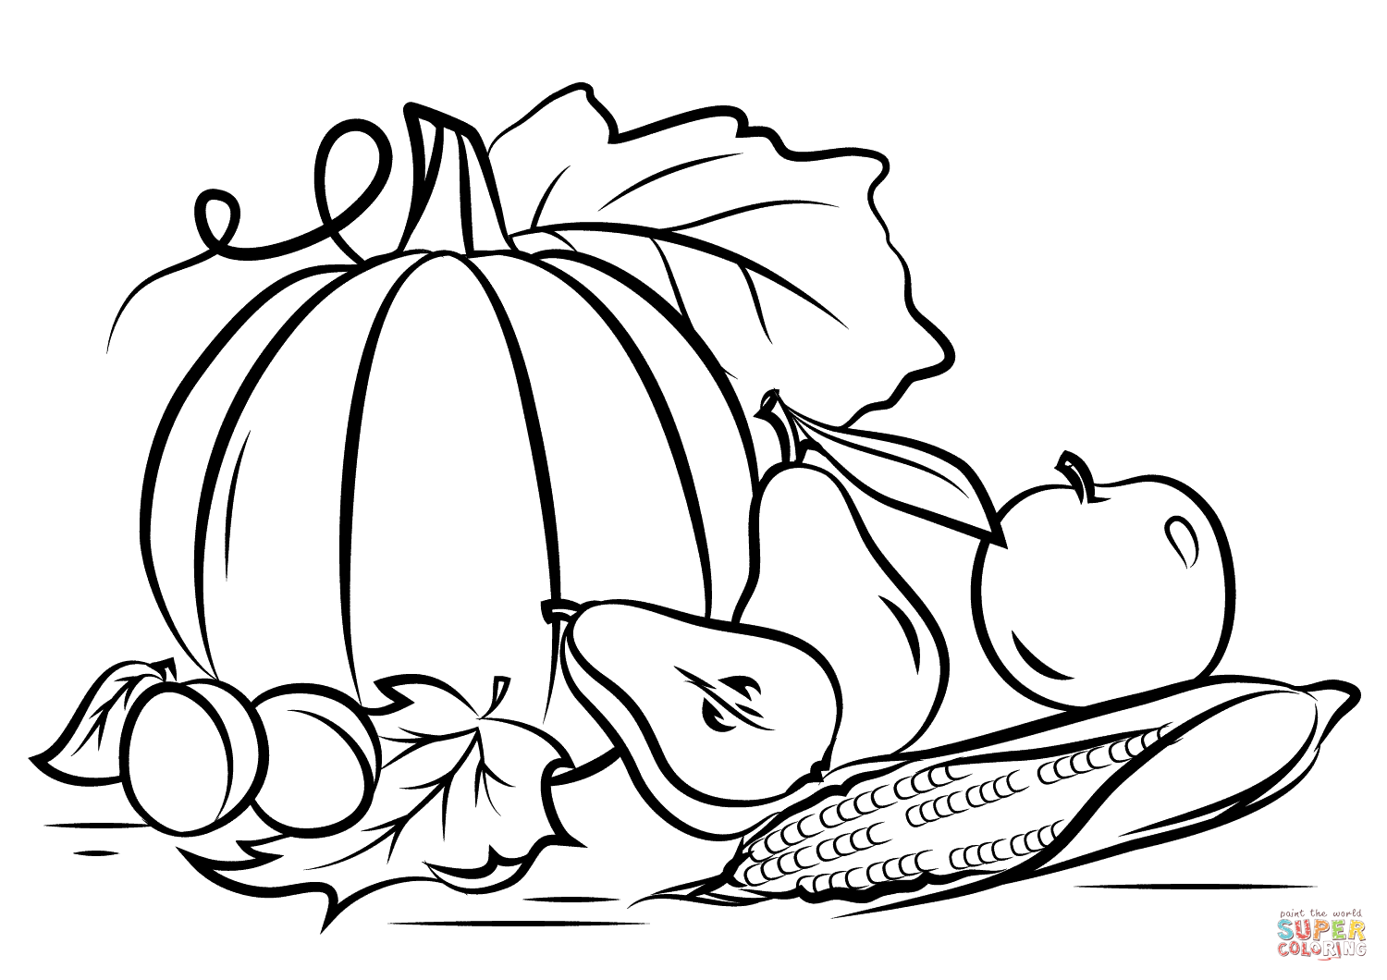
TEEN FALL
COLORING CONTEST

Why should kids have all the fun?
Stop by at the Ref. Desk & pick up one of two designs
to show off your Creativity
November 1st-30th.
Prize will be awarded to the winner and notified by phone
You can use colored pencils or crayons!
This program is for Teen 13- 17

Switzer Library, 266 Roswell St. Marietta Ga
770-528-2377
Teens Coloring Contest

